

Name :Muhammad Shaheer

Roll no: 20p-0480

Lab task: 4

NATIONAL UNIVERSTIY OF COMPUTER AND EMERGING SCIENCES, FAST- PESHAWAR CAMPUS

**LAB TASK:** Inter LAN Communication in CPT

Design the following topologies and perform simulation in packet tracer.

• Assign IP Address of Class C

• Transfer packet between them.

**LAB TASK 1:**

**Steps:**

**Open Cisco Packet Tracer:** Launch Cisco Packet Tracer and open your existing project or create a new one.



You have to make some arrangements of your network like this now let’s move towards it IP Configurations

As we have already learned how to assign IPs to devices so here we go towards IP configuration of Routers.

So in router we have two ports to work with.

**Router port 0 IP Configuration:**



**Router port 1 IP Configuration:**



Now by setting your Routing settings lets run ping command and see it’s your connection is established successfully or not.

Note: Due to override of lab task 1 on task 2 not is able to take snaps of routing static settings but it is working fine and check in lab by Lab instructor.

We will see these routing settings in details in lab task 2

So now run ping command on command prompt and see their results

**For PC 0:**



**For PC 2:**



LAB TASK 2: Communication using two Routers

Steps:

**Open Cisco Packet Tracer:** Launch Cisco Packet Tracer and open your existing project or create a new one.

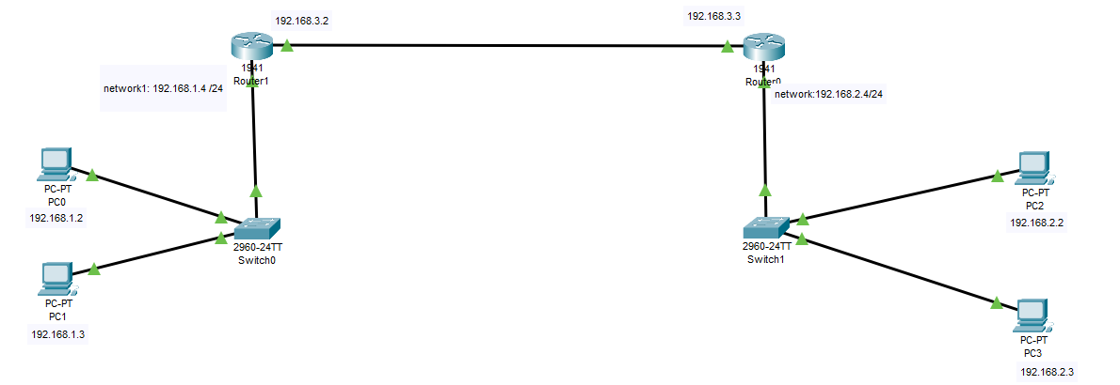

You have to make some arrangements of your network like this now let’s move towards it IP Configurations

Assign IPs and also to routers

**For pc 0:**

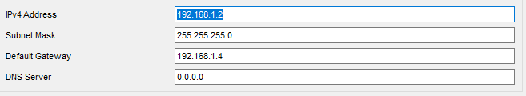**For PC 1:**

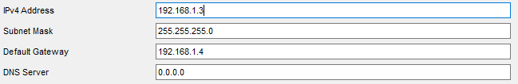**For PC 2:**

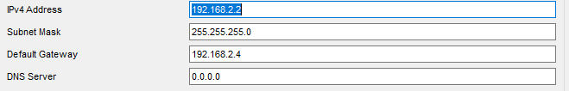**For PC 3:**

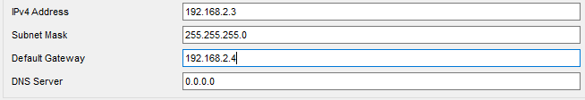**For Router 0 Ethernet 0/0:**

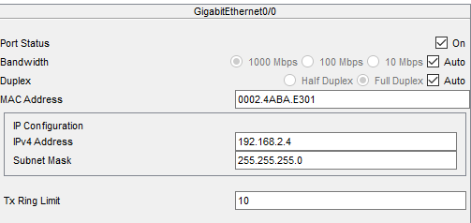

**For Router 0 Ethernet 0/1:**

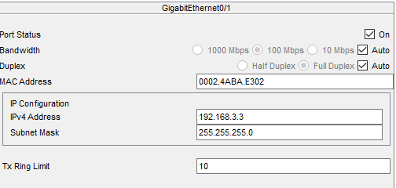

**For Router 1 Ethernet 0/0:**

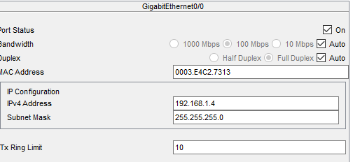

**For Router 1 Ethernet 0/1:**

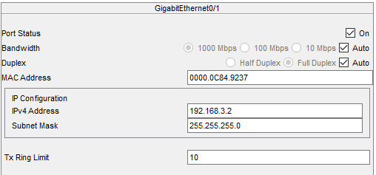

**Now send a message and let see what happened**

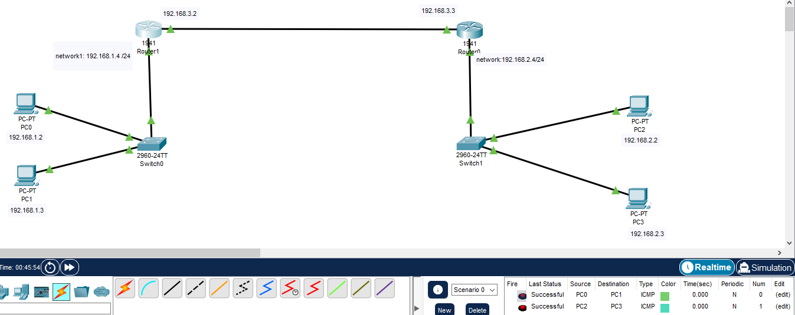

**See the message is successfully transfer for just two networks**

**Now try to send message from one network to another**



**It Failed due to incomplete routing**

**Now let’s move towards routing**

**Now go to router 1 and in routing click on static and do following settings**

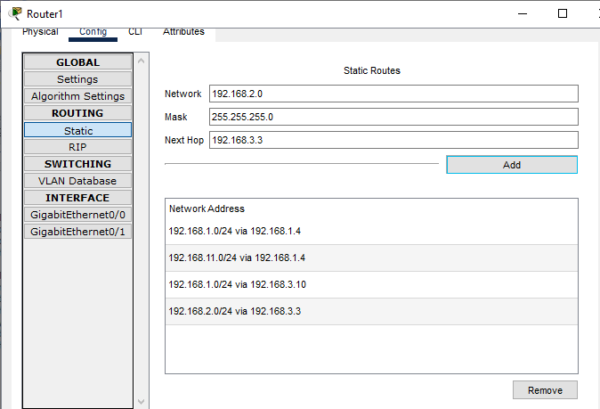

**For router 0:**

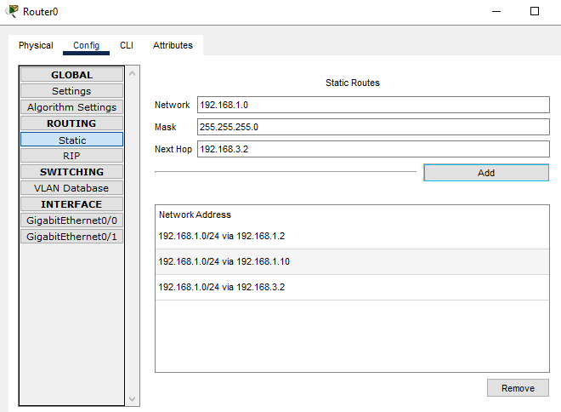

**Now after doing this lets try again and send message it takes some time to establish network try at least 2 to 3 times**

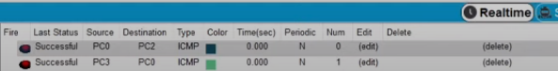

**So it is successfully connected**

**LAB TASK 3:**

**Communication using three routers**

**Steps:**

**Open Cisco Packet Tracer:** Launch Cisco Packet Tracer and open your existing project or create a new one.

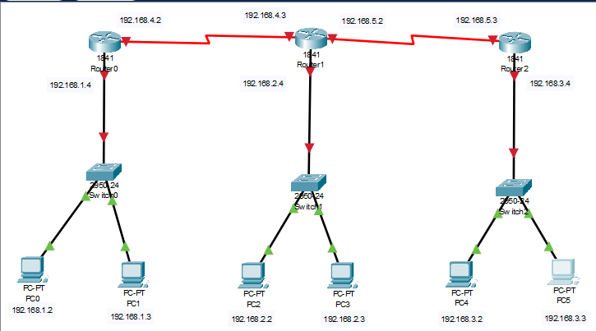

**Assign IPs and Router IPs like this**

**For PC 0:**

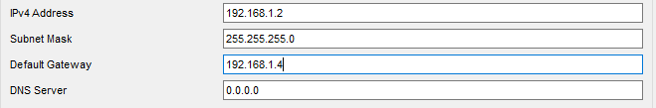

**For PC 1:**

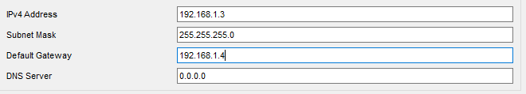

**For PC 2:**

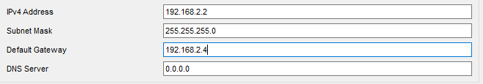

**For PC 3:**

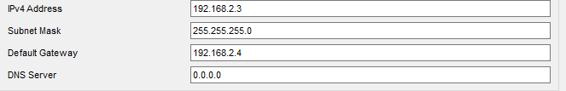

**For PC 4:**

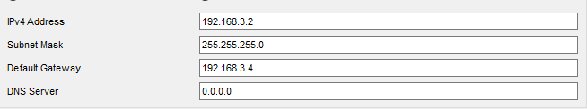

**For PC 5:**

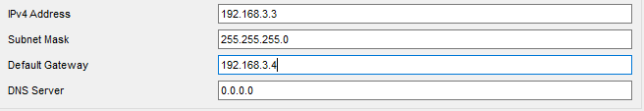

**For Router 0 port 0/0:**

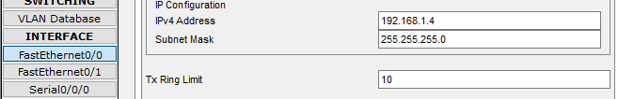

**For Router 1 port 0/0:**

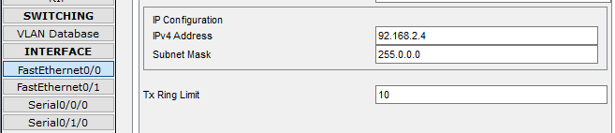

**For Router 2 port 0/0:**

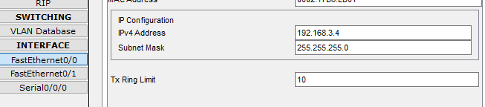

**For Router 0 Serial port 0/0:**

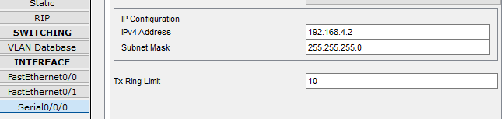

**For Router 1 Serial port 0/0:**

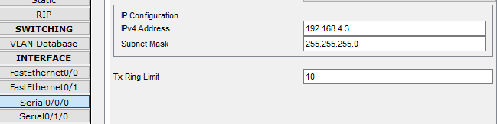

**For Router 1 Serial port 1/0:**

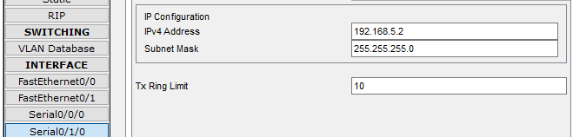

**For Router 2 Serial port 0/0:**

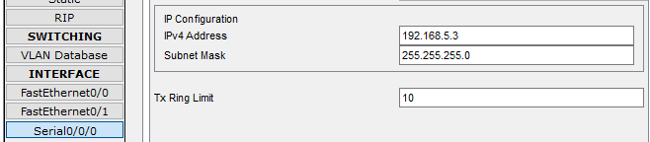

**Now our network looks like this**

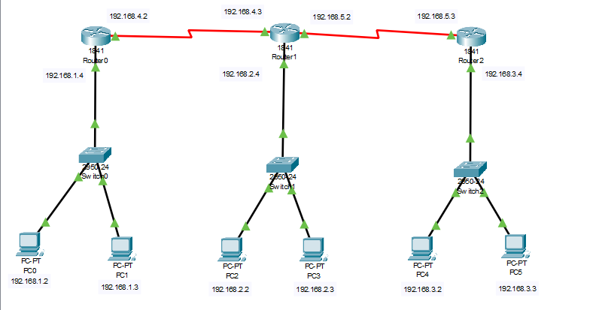

**STATIC ROUTING FOR ROUTER 0:**

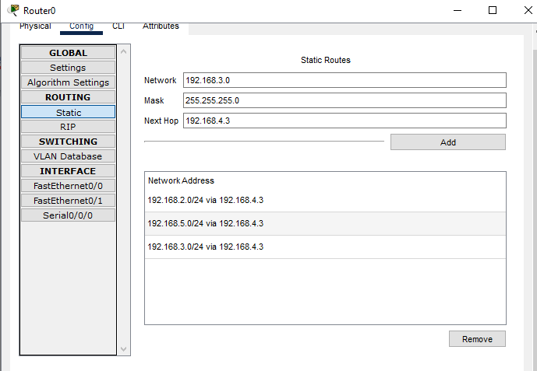

**STATIC ROUTING FOR ROUTER 2:**

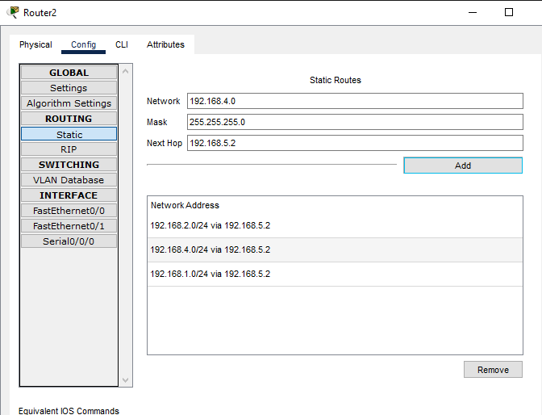

**STATIC ROUTING FOR ROUTER 1:**

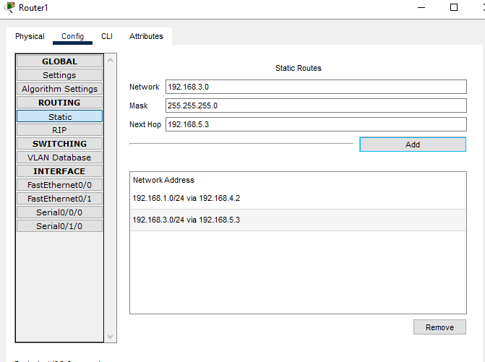

**Now let’s run ping command or send message through GUI**

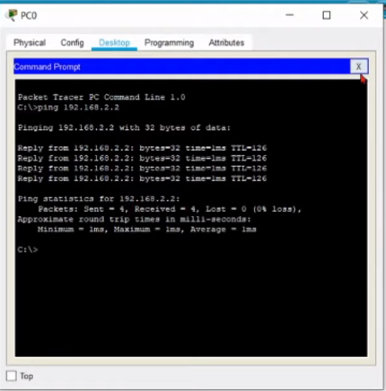

**Or:**



**So our connection is successfully established.**